LockedMe.com

Software Requirements Specification

1.0

14-02-2023

Developer:

Alexandru Olteanu

## Introduction

Company Lockers Pvt. Ltd. aims to digitize their products and chose LockedMe.com as their first project to start with. This document provides details on product’s capabilities, appearance, user interactions.

## Purpose

The purpose of this document is to capture the product details below.

* Product’s capabilities, appearance, and user interactions
* Project and developer details
* Sprints planned and the tasks achieved in them
* Algorithms and flowcharts of the application
* Core concepts used in the project
* Links to the GitHub repository to verify the project completion
* Your conclusion on enhancing the application and defining the USPs (Unique Selling Points)

## Product Capabilities

The product is a software application that provides the options to users to perform the below activities

* + Retrieve the file names in an ascending order
  + Add a user specified file to the application
  + Delete a user specified file from the application
  + Search a user specified file from the application
  + Close the current execution context and return to the main context
  + Close the application

**Process Flowchart**

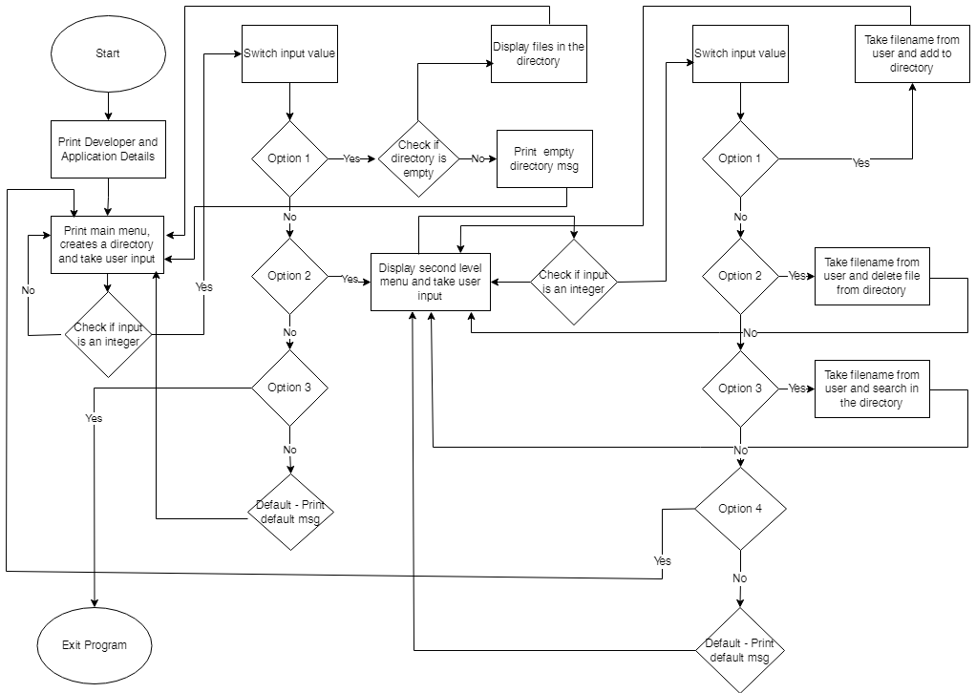

### User Interfaces

**GUI**  
As this is a prototype application, there is no GUI interface.

**CLI**  
User interaction will be via command line

**APPLICATION FLOW**

Step1 - Application starts by displaying developer and application details, creates a default directory, and display first level option to user.

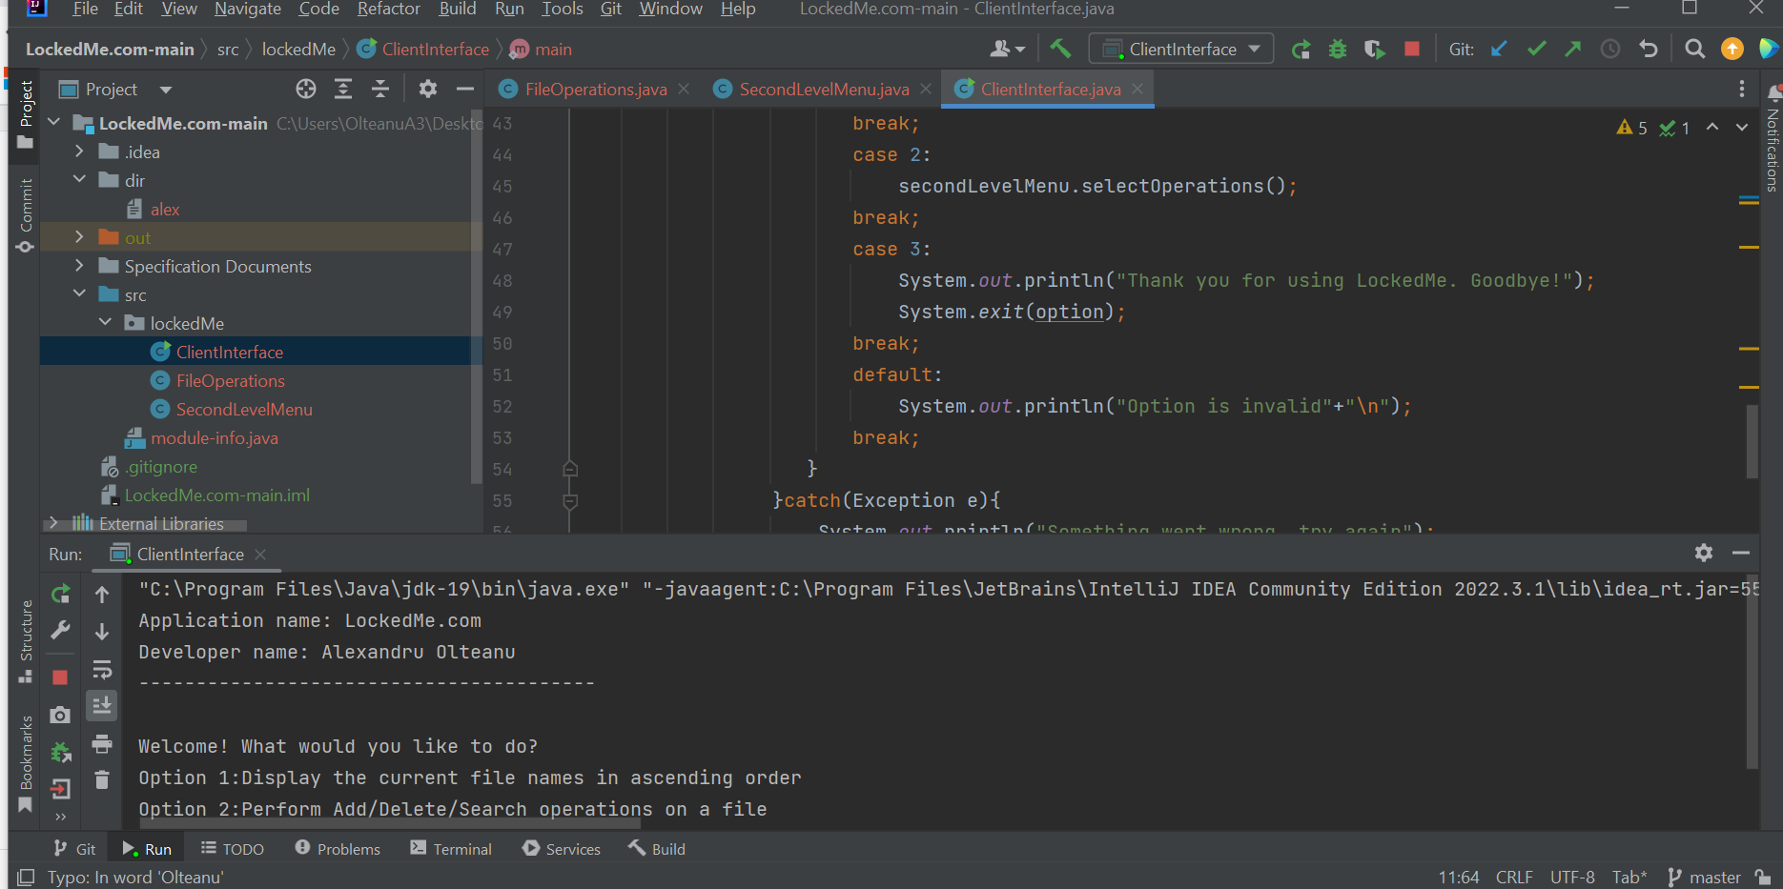

Step 2: Take user input and check if input is valid. It checks whether input is an integer or wether input is from the list of options.

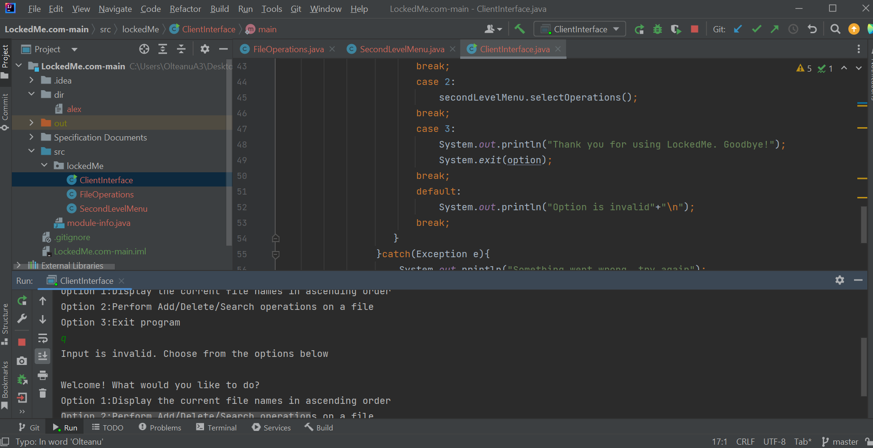

Step3. Diplay empty directory if option 1 is chosen prior to adding files.

At this point, there is no file in the default directory and user needs to add files first before dsplaying

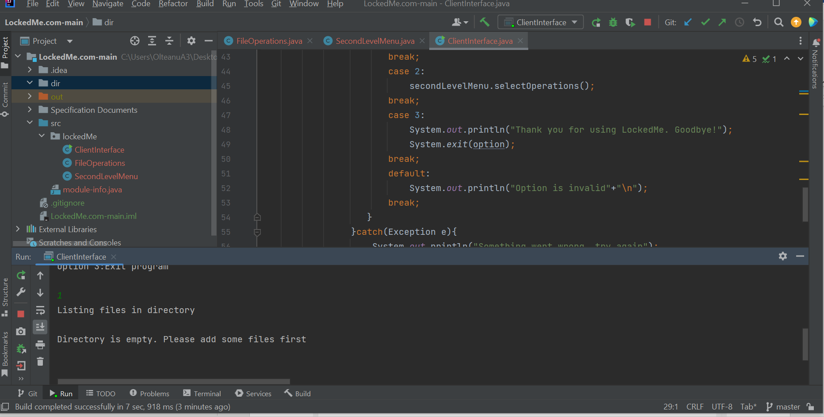

Step4 – Enter second level menu and choose any option

User enters the second level menu which also checks for validity of input

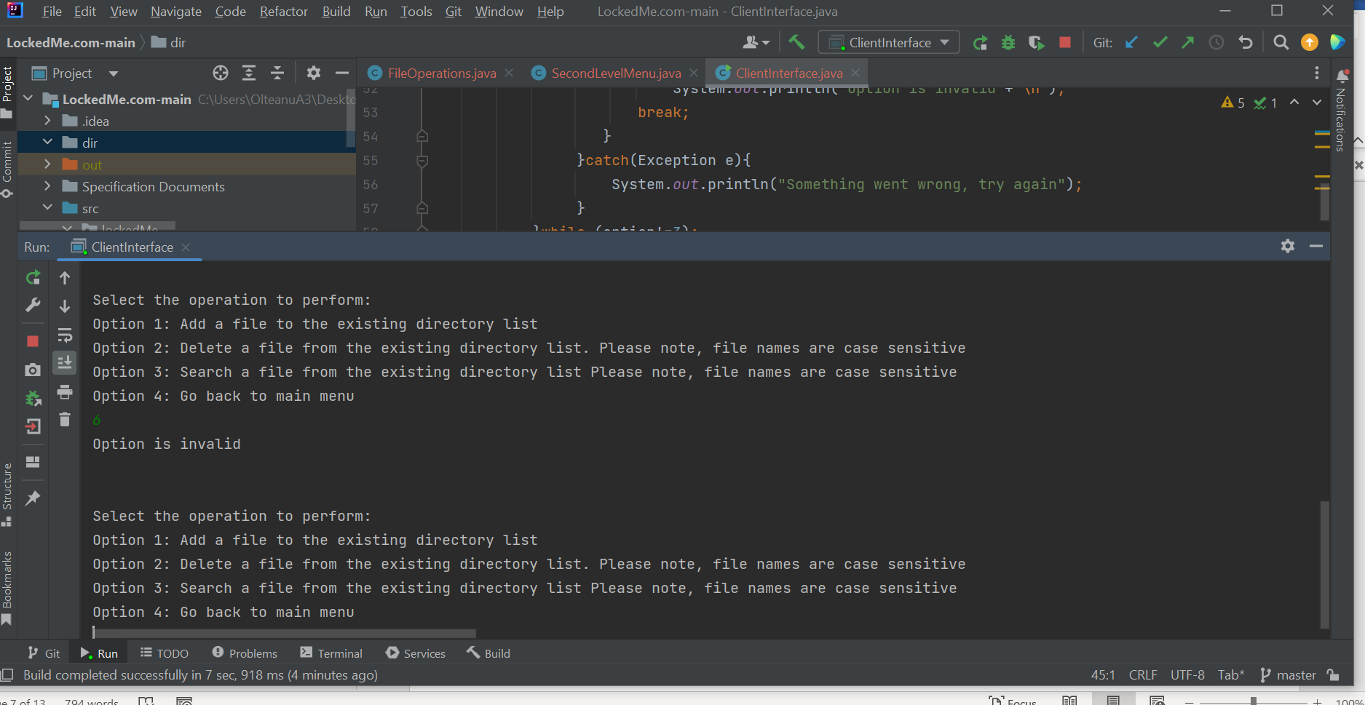

Step5: User enters correct input and file is added successfully and can be displayed.

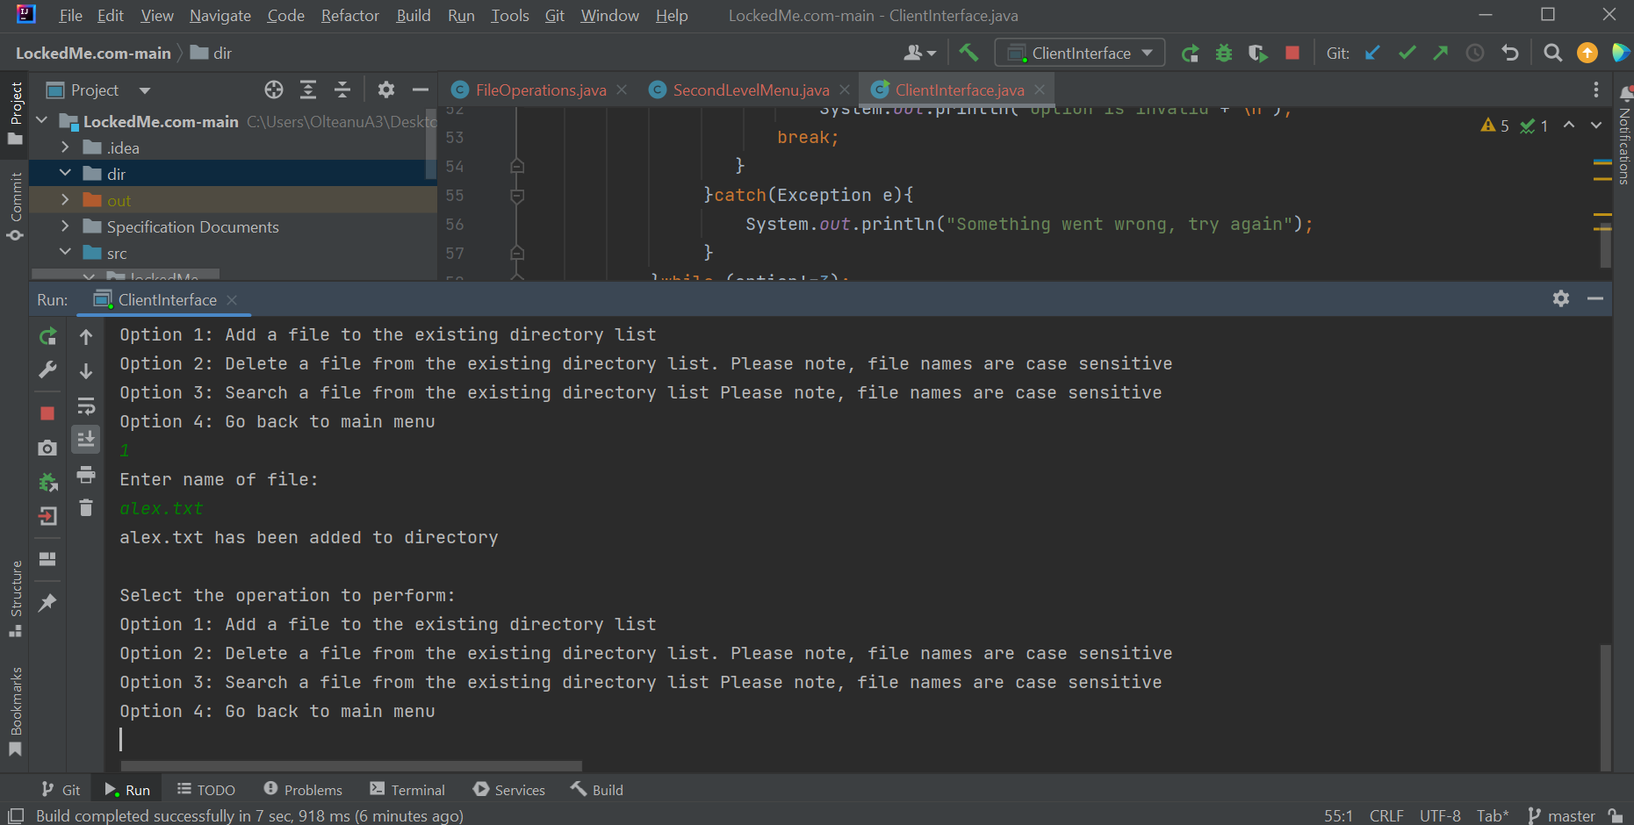

Step 5: User can add as many files as he wants

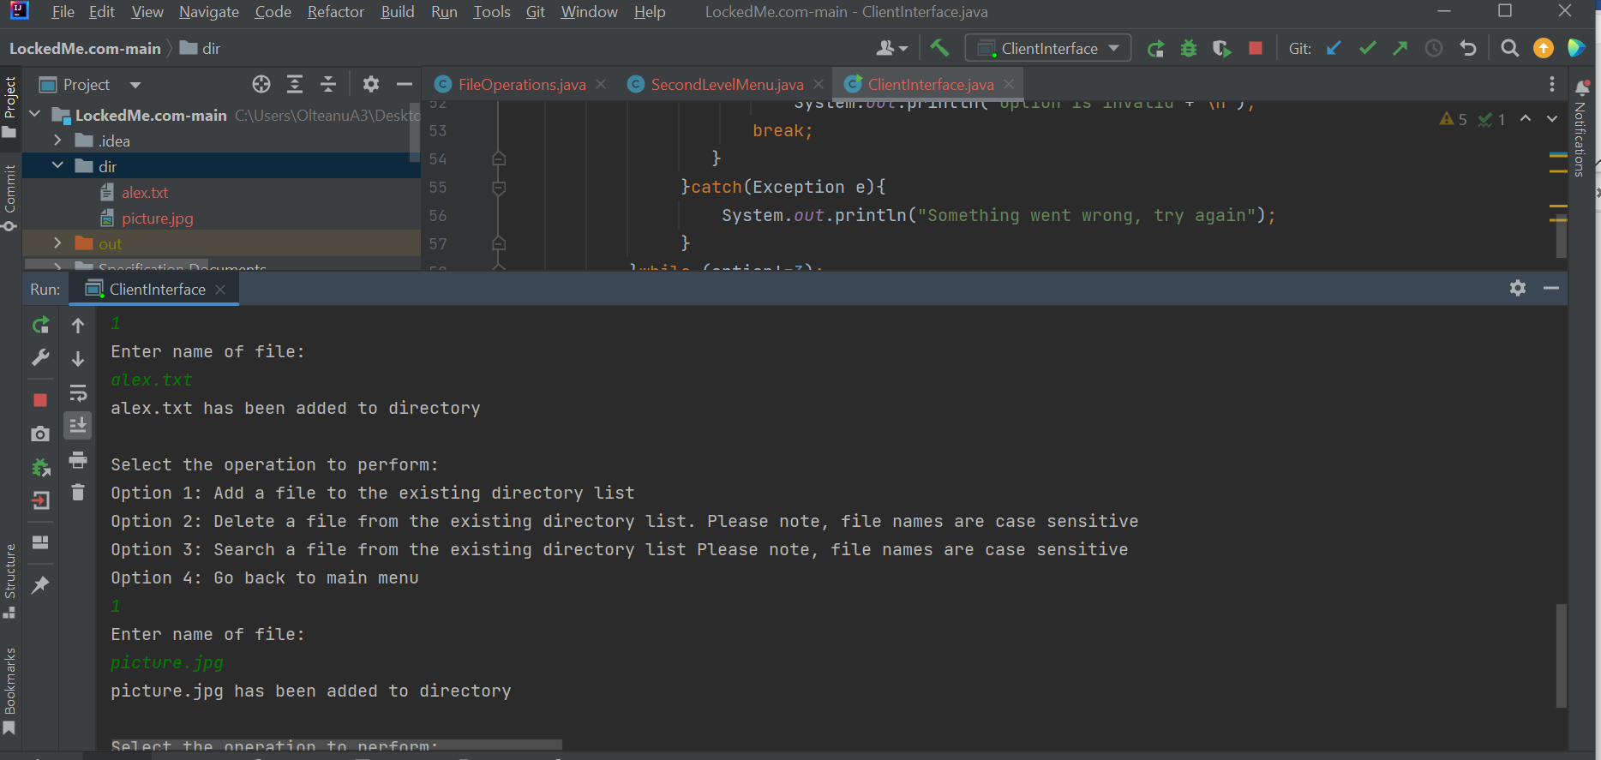

Step6: User attempts to delete a file.

Filenames are case sensitive to ensure that the correct file is deleted

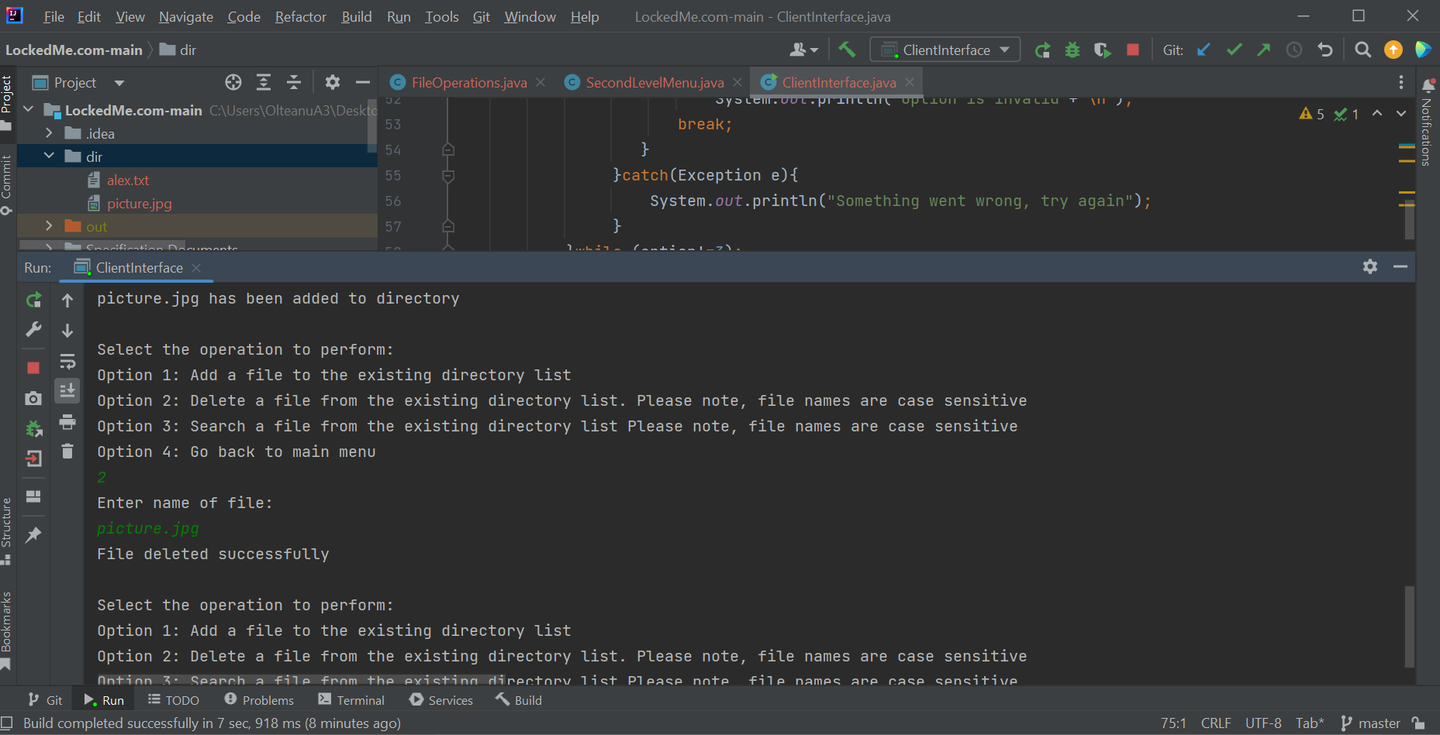

Step7: User enters input and filename to search for a file. File is case sensitive so will not find files wit case mismatch.

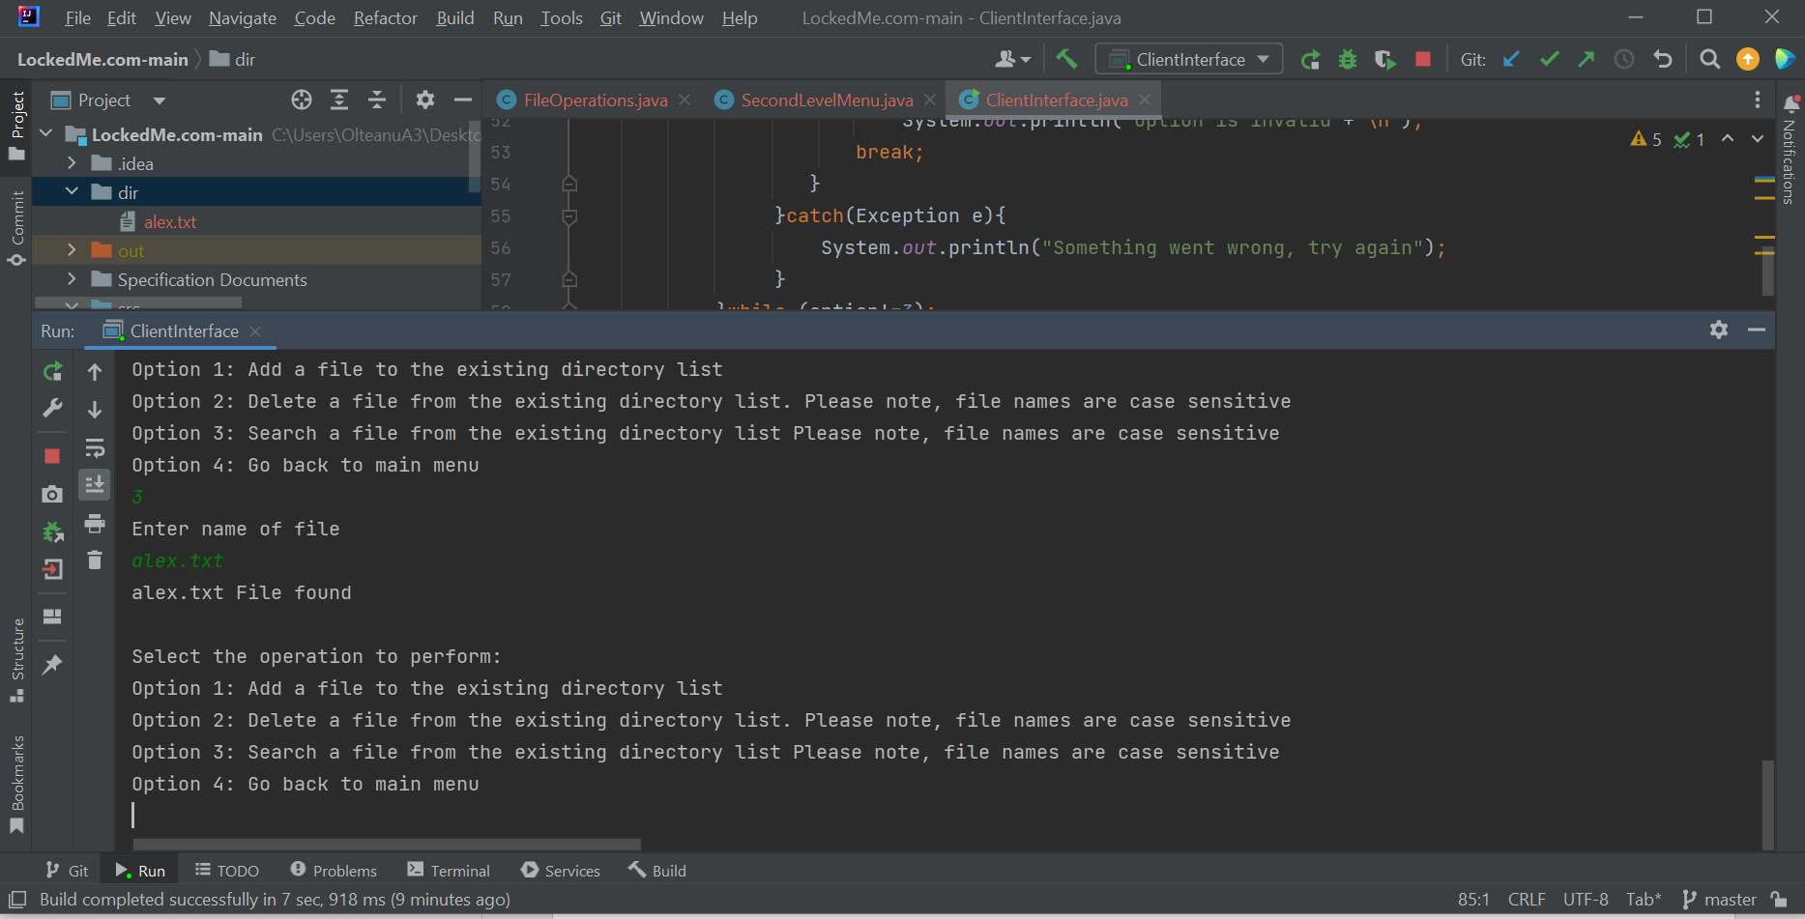

Step8: User select option to return to main menu

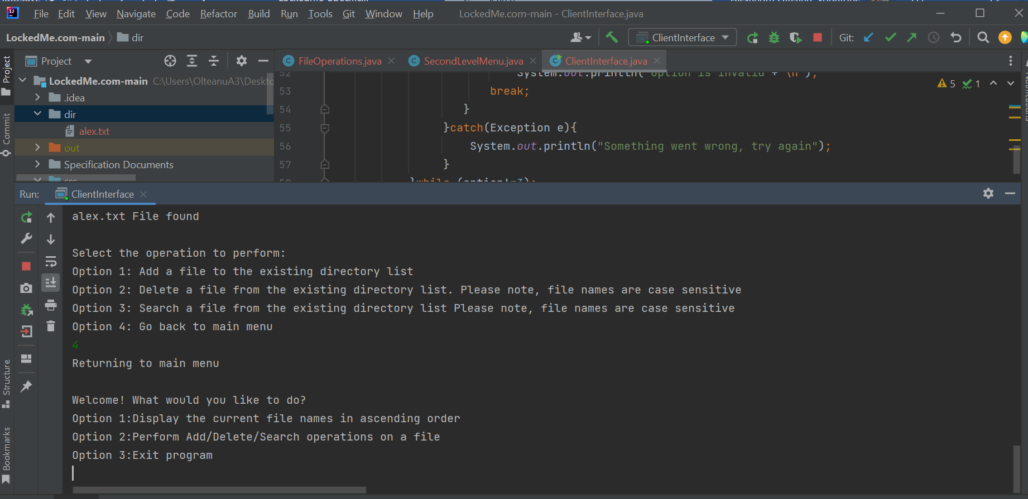

Step 9: User displays files in the directory

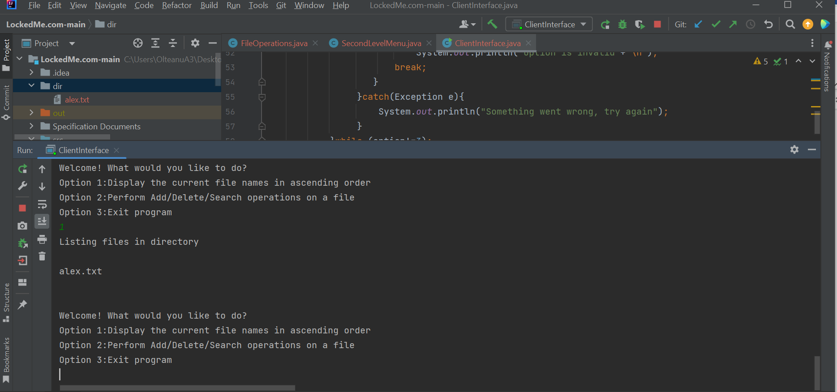

Step 10: User exists the program

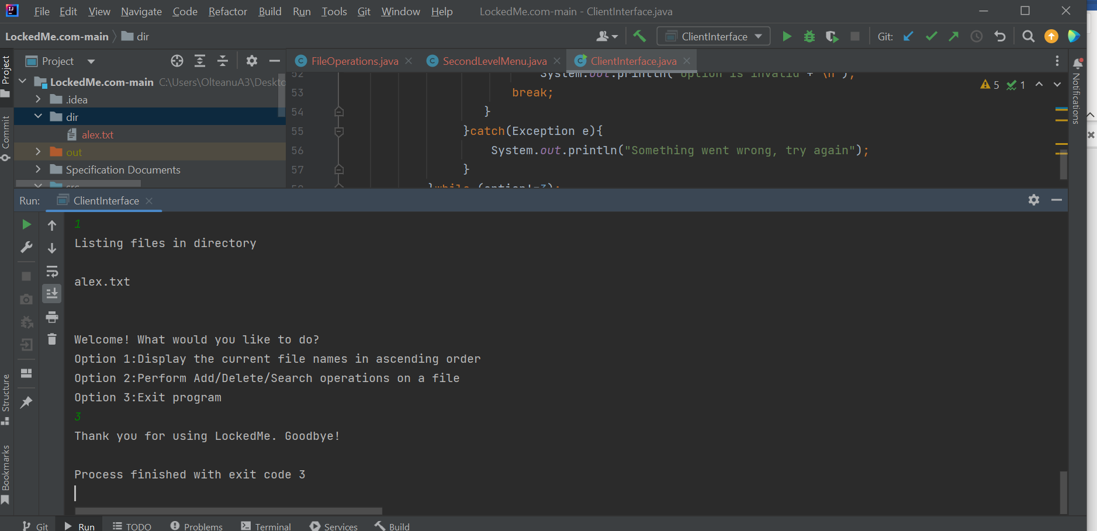

**SPRINT PLANNING**

The functionalities were converted to below user stories with story points assigned and placed in the product backlog. LM – (LockedMe)

|  |  |  |
| --- | --- | --- |
| Story ID | User Story (Product backlog) | Story points |
| LM01 | As a user, I want to see operations I can perform on the application | 1 |
| LM02 | As a user, I want to display all files in a directory so that I see all available files | 3 |
| LM02 | As a user, I want all files displayed to be sorted in an alphabetical order so that I can identify files easily 8 story points | 5 |
| LM04 | As a user, I want to navigate into business level operations so that I can perform specific activities | 5 |
| LM05 | As a user, I want to add files to the directory so that I can keep my work-related documents 5 story points | 5 |
| LM06 | As a user, I want to delete specified files in the directory so that I remove files that are no more relevant to work | 8 |
| LM07 | As a user, I want to search the directory so that I can find files quickly. | 8 |
| LM08 | As a user, I want to return to the main menu when I’m in a business operation menu level so that I can perform other operations in the main menu | 3 |
| LM09 | As a user, I want to exit the application when I am done with my operations. | 1 |

**The application was completed in 3 sprints with breakdown below.**

Sprint 1 || Stories - LM01, LM02, LM07 || Total points – 12

Sprint 2 || Stories LM09, LM05, LM06 || Total points – 14

Sprint 3 || Stories LM02, LM04, LM03 || Total points – 12

**CORE CONCEPTS AND ALGORITHYMS USED**

* Exception Handling
* File Handling
* Sorting
* OOP
* Arrays

## Link to the GitHub repository

[**https://github.com/alex0890/lockedme.git**](https://github.com/alex0890/lockedme.git)

**CONCLUSION**

**Some unique selling points of the application are**

1. The application keeps running to accept user input which allows user to manipulate his was through and terminates when user selects the appropriate option.
2. User can navigate seamlessly within the application from one menu option to another without the code breaking.

**Future Enhancement of application**

1. The application can be enhanced such that, it will take directory name from user and create without having a dependency on the local drive developed on.
2. Additionally, sorting can be enhanced to allow user to choose whether to sort by ascending or descending or by date.